**CS 210**

**Lab 12: GUIs**

**Lab Date:** Tuesday, April 16

**Due Date**: Tuesday, April 23, 11:59pm

**Submission**

* This is an **individual** lab.
* Submit all files in a single zip file to the Lab 12 assignment folder on Kodiak.

**Goal:** Implement simple GUIs.

**Part I**

Western New England University is establishing new prices for its dorms and meal plans. Under the new plans, dorms have the following rates per semester:

* Plymouth: $1200 per semester
* Commonwealth: $1500 per semester
* Gateway: $1600 per semester
* Southwood: $1800 per semester

Additionally, meal plans have been adjusted to the following rates:

* 7 meals per week is $600 per semester
* 14 meals per week is $1100 per semester
* Unlimited meals is $1500 per semester

Create a GUI with two dropdown boxes (Hint: The relevant class is JComboBox), one for dorms and one for meal plans. When the user selects a dorm and meal plan, a label or text field at the bottom of the GUI should show the total price.

**Part II**

At a nearby bagel shop, customers have a couple of options. Plain bagels cost $1.25, while Everything bagels cost $1.50. Customers can also select toppings: Cream cheese costs 50 cents, butter costs 25 cents, jelly costs 75 cents, and jam costs 75 cents. Some people are weird and use multiple toppings on their bagels, and the owners are okay with that. Customers can order coffee, where regular coffee costs $1.25, decaf coffee also costs $1.25, and cappuccinos are $2.00.

Construct a GUI that looks like the one below. After clicking the Calculate button, a window should pop up showing the total price. After clicking Exit, the program should end.

Hints: This example uses the JCheckBox class, and the createTitledBorder() method of BorderFactory.

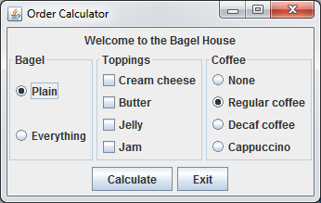

**What to Submit:**

* A zip file containing all source files.